Federation of Business Disciplines Journal

Volume 15, 2023 p 12 - 23

CLOSING THE DIGITAL DIVIDE WITH HOME-BASED SOLUTIONS FOR LOW- INCOME POPULATIONS
Jennifer D Milczewski
University of Texas Rio Grande Valley
Edinburg, Texas 78539

ABSTRACT

This is a call for collaborative support from federal policy makers to focus on closing the digital divide in low-income communities like the Rio Grande Valley of Texas by using a cooperative funding approach between the U.S. Department of Housing and Urban Development and the Federal Communications Commission. With additional targeted federal support, we can ensure that low-income persons do not fall further behind by supporting tech equity in these disadvantaged households. This paper presents issues related to technology inequities, possible solutions, and tangible recommendations for empowering communities to improve internet accessibility and digital literacy rates.
Keywords: technology inequity, low-income communities, home-based solutions.

INTRODUCTION
A known cause of poverty is lack of access to knowledge / data, and other resources that are needed to rise into higher levels of education and wellbeing. Improved internet infrastructure, discounts on computing equipment, and digital literacy training can provide hope. The current Biden Administration has recognized the need to close the digital divide in underserved communities, but additional strategic implementation is needed through interagency collaboration and home-based solutions.
Over $100 Billion (McKinsey & Company, 2022) in federal funding has been pumped into the economy with the goal of closing the digital divide using programs like the Emergency Broadband Benefit, Emergency Connectivity Fund, Affordable Connectivity Program, and many others. These programs focus on providing eligible U.S. households, libraries, and schools with discounts on computing equipment and broadband connections to support virtual classrooms, and post-COVID work from home job search efforts (FCC: Homework gap and connectivity divide, 2022). The Federal Communications Commission (FCC) has been charged with administering the lion’s share of funding opportunities into these initiatives aimed to improve digital equity in underserved populations (FCC commits another $86M in emergency connectivity funding, 2022).
Analysis of this spending is crucial and urgently needed to ensure funding dollars are going to those in need so that they are not left behind. Collaboration and streamlined fund-sharing between the FCC and The U.S. Department of Housing and Urban Development (HUD) will improve outcomes and will ensure that low-income households do not fall further behind in the digital divide.
This paper looks at the Rio Grande Valley of Texas as a special case example, but there are many regions around the country that need additional attention as well. In the wake of the pandemic, the growing gap in the middle class, along with the further decline of the lower class is more apparent now than ever. This is a call to action to ensure these beneficial government programs are being implemented in places around the U.S., including places like South Texas, where they are urgently needed.

BACKGROUND
South Texas is notoriously impoverished; the five poorest counties in Texas are along the Texas- Mexico border region between Laredo and Brownsville.
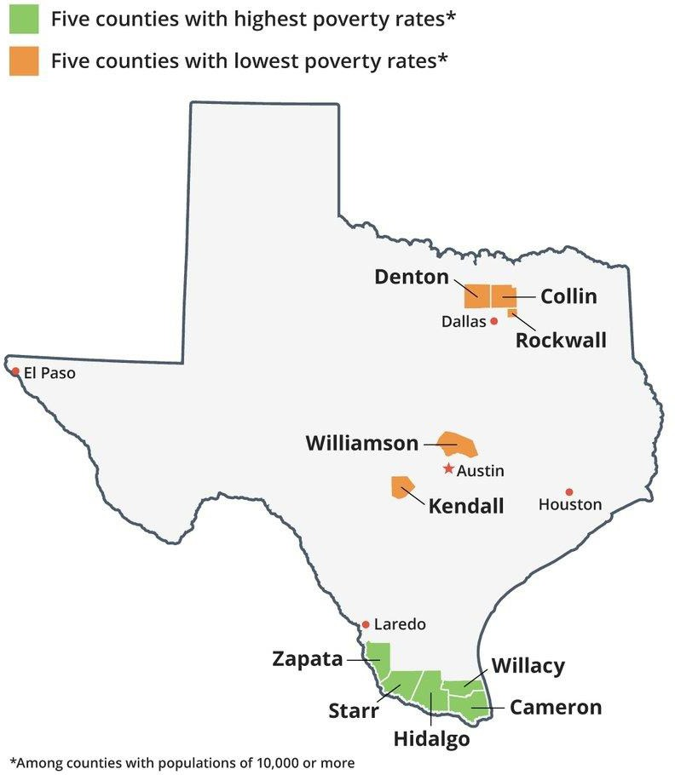
Figure 1: Poverty prevalent on Texas border (Ura, 2016)

These poverty rates coincide with high levels of digital inequity.

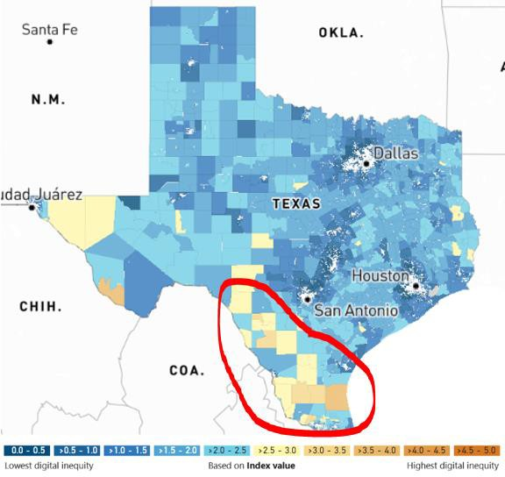
Figure 2: Digital Inequity in South Texas (Endicott, 2022)

In many regions around the US, poor or no internet access is systemic, especially along the Texas-Mexico border, which is one of the least connected regions in the country (Smith, 2021). In fact, a 2019 analysis by the National Digital Inclusion Alliance found that three of the five worst-connected cities in the country are in the Rio Grande Valley (Zappie-Ferradino, 2020).
In this COVID era, the digital divide continues to further separate the lower- and upper- classes of this already impoverished region and in many other regions across the country. Federal subsidies are needed (Wheeler, 2020) to improve internet service to low-income Americans, since improved internet and digital literacy improves economic growth (Katz, 2012).
Adequate computing devices are necessary for accessing telehealth services, applying to jobs, finding success in school, working from home, and allowing individuals to participate in important digital communities.
Internet connectivity, adequate devices, and basic digital education are necessities, not luxuries and lack of access to these important resources can severely ostracize low-income individuals from society today (Cookson et al., 2020). Many Rio Grande Valley residents lack access to resources needed to take advantage of digital technologies due to a lack of reliable internet broadband access (Garnham, 2021). The problem is exacerbated because the most impoverished areas are rural / remote.
Sixty percent of Hispanic respondents report being underprepared with digital skills; this figure may be even higher in South Texas. Lack of technology literacy skills greatly impacts the employability of this demographic: intervention is critical to close this gap; if not “a majority of Black and Hispanic workers could be locked out of 86% of jobs by 2045.” (Chakravorti, 2021)
Broadband access and computer literacy training are increasingly critical to involvement in our society, the economy, health services, and educational institutions (Clyburn, 2021). Additional support for broadband will also lead to higher levels of employment.
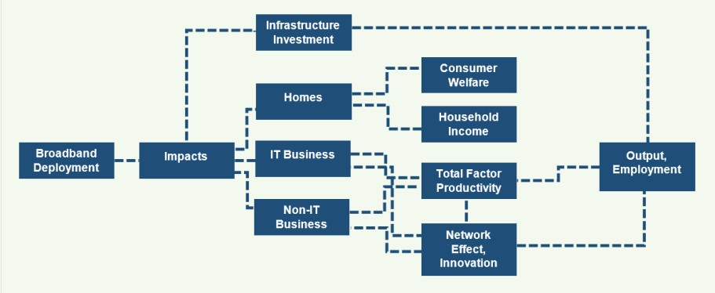
Figure 3: Economic Impacts of Broadband: Additional support will lead to higher employment (Lee, 2019)

The social and economic implications of the digital divide in South Texas have been impacting residents’ ability to connect with important services like education, online banking, jobs, medical care, and social connectivity (Reddick et al., 2020). A well connected and educated community typically enjoys benefits that include crime reduction and an increased sense of social responsibility amongst its citizens. In this post-COVID era, it has become clear that continued investment in the Rio Grande Valley’s digital infrastructure is critical to this region’s ability to contribute to higher levels of success in Texas.
The geography of this region poses a topographical challenge for broadband infrastructure. On one hand, the southern tip of Texas is a gateway to Latin America and a hub for international trade with our Mexican neighbors, which may present an opportunity for international collaboration for improvements to building out broadband infrastructure. On the other hand, it is a very isolated region when compared to cities and towns that lie in the United State’s interior.

ANALYSIS OF SOLUTIONS
Many low-income regions around the U.S., including the Rio Grande Valley are in need of focused support to improve digital equity, which includes a three-part approach:
- Expand broadband infrastructure (i.e. fiberoptics, DSL, cable / wireless networks),

- Improve access to low-cost computing equipment and low-cost internet access, and
- Enhance digital literacy training.
High-earning communities and households have more opportunities to achieve these targets, but impoverished neighborhoods do not have adequate representation in these areas.

Option 1: Focus funding on local libraries
Libraries in low-income communities have so often been the focal point for achieving digital equity, and they are important public spaces, but this is not the answer, as many of the lowest income individuals lack the necessary transportation to travel to these places and they are limited in many ways, specifically in rural areas. In urban communities, libraries can often have long wait times to use computers, and some limit patrons to use computers in stretches of only an hour or less at a time. In addition, those looking to improve their access to digital knowledge can only access libraries during limited hours, which may not be accommodating to every schedule, and does not allow for individuals to work remotely. Many libraries have a huge demand for limited resources, which has outpaced the capacity of their computer labs and connectivity bandwidth (Crawford, 2014). During the early days of the COVID-19 pandemic, many libraries had to further limit access to their computing equipment, which only caused growing inequity for low- income populations (Brooks, 2020).

Option 2: Increase federal oversight with forensic accounting audits of Internet Service Providers (ISPs)
If we could trust for-profit ISPs to always act in a spirit of lifting up underserved communities, broadband access would have never been an issue in the first place. Additional accountability is needed so large oligopolistic conglomerates like Spectrum, Comcast, and Cox don’t take advantage of citizens and federal dollars through price gouging. Frequent 3rd party audits are needed, as ISPs are notorious for hiding key details (Brodkin, 2021). A clause on routine transparency audits should be added to the Broadband Consumer Transparency Act of 2021 (Craig, 2021).
Many people view ISPs as a public utility like electricity or water. However due to the high-tech nature of the internet, competition is often necessary to ensure the people are getting high-quality access to data, so the public stays ahead of the curve in the global technology sector.
Transparent government partnerships with private firms are of key importance here.

Option 3: Let the free markets rule: reduce government intervention
The red tape and bureaucracy of government intervention can be stifling to the innovation of the tech sector. Organic, grassroots progress is often the best option in a free market system.
Perhaps the Rio Grande Valley and other similar regions aren’t ready for improved technological equity. One factor that attracts people to low-tech regions is the slower pace of life, so sometimes stimulating growth in areas that are sluggish to adopt new technologies can cause a slew of unforeseen problems. Unchecked and artificially stimulated economic growth caused by injecting too much federal funding into this region’s tech assets can cause some problems, but the alternative (of not accepting federal funding) will lead to a more dismal situation. Reducing government intervention is not the answer.

Option 4: Develop a partnership between the Federal Communications Commission (FCC) and The U.S. Department of Housing and Urban Development (HUD) to improve digital equity in low-income households
The best way to tackle digital inequity is to start at home, which is where the U.S. Department of Housing and Urban Development comes in to play.
A targeted national approach is currently being implemented through a collaborative effort between HUD and the FCC, where low-income housing voucher / section 8 recipients are being informed about the Affordable Connectivity Program through their local Public Housing Authorities (PHAs), using targeted messaging campaigns. There is even a specific division of HUD, called ConnectHomeUSA which is working to close the digital divide in HUD-assisted housing. So, work is being done in this area, but more efforts are needed.

RECOMMENDATIONS
A blending of the four aforementioned options is already being implemented in areas across the U.S., however, it would be most beneficial to expand upon Option 4: Develop a partnership between the FCC and HUD to improve digital equity in low-income households for the remainder of this paper. By focusing on the homes of hard-to-reach federal housing residents, HUD and local PHAs have been able to overcome many barriers and help traditionally underserved populations as shown below.
Figure 4: Strategies for Engaging Hard-to-Reach Residents (HUD ConnectHomeUSA Virtual Summit, 2021)
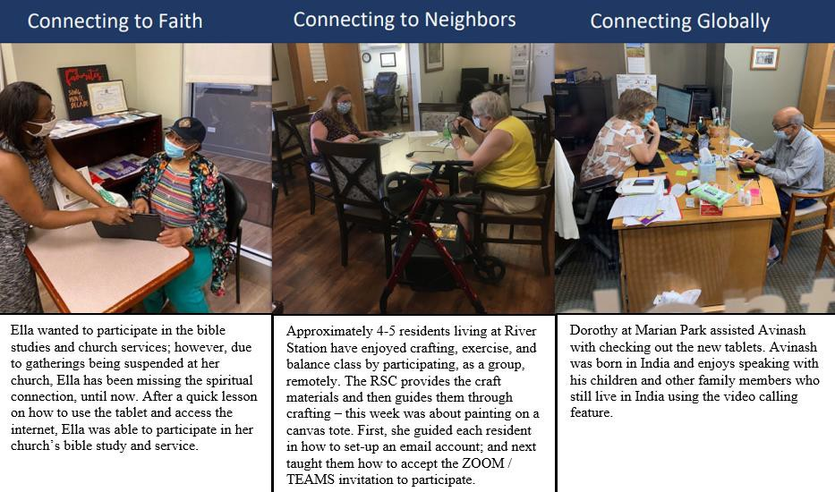
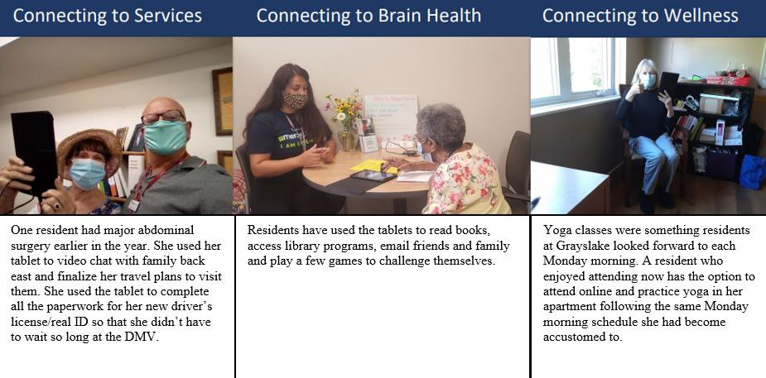

“I wish I had your supervisor’s email to tell her how wonderful these devices are and about the great job you are doing for us; you deserve credit”. Candice shared that the use of the tablet and speaking with the RSC has helped reduce her anxiety and depression. She said she feels more
energetic and less isolated.” -Candace, Resident

Recommendation 1: Targeted grants aimed at low-tech communities
The FCC recently announced a $5 million competitive grant opportunity to kickstart a one-year pilot program called “Your Home, Your Internet” (WC Docket No. 21-450; FCC-CIRC2208-02, 2022), which will improve outreach surrounding the Affordable Connectivity Program, a program that offers a discount on monthly broadband access and computing equipment for low- income households. Although $5 million may seem like a lot, the program guidelines dictate that only 20 out of a total of 3,300 total PHAs will be allowed to participate in the program, if their application is satisfactory (Public Housing HUD.gov, n.d.). Instead of approving grant applications based on which PHAs apply, specific regions with low digital equity (like the Rio Grande Valley) should be targeted first and offered technical assistance with completing application materials. This will allow for low-tech communities a first option at participating in this program, that would likely benefit their residents the most.

Recommendation 2: Codify Housing Standards Regulations to include broadband access
One hundred years ago, in many communities across the country, electricity was considered to be a luxury, however it’s now viewed as a critical component to a safe home. Same goes for broadband and computers today. It is a codified rule that federally assisted households must have safe electricity, indoor plumbing, and cooking appliances like a stove and refrigerator. It is now time to include broadband as a standard utility and perhaps computing equipment as a standard household appliance as well.
I am recommending that HUD include a mandatory inspection for broadband access in all HUD- assisted homes in their new National Standards for the Physical Inspection of Real Estate, also known as NSPIRE, which are currently in the process of being developed (National standards for the physical inspection of real estate HUD, n.d.). Inspectors should be trained to not only document and report lack of broadband access during inspections, but also to inform tenants of resources provided by other agencies meant to remedy this issue, including the Affordable Connectivity Program administered by the FCC.
Because there is no mention of internet access in The HUD Public Housing Modernization Standards Handbook, I recommend adding a section under 7-8B. (Emergency Call Systems) and 7-9B (Television Antennas), which should state the following:
7-10B. BROADBAND. Broadband internet access is to be provided in all multi-family projects. The monthly service fee may be the responsibility of the residents where other funding for low- income housing broadband access is not available.
(The Public Housing Modernization Standards Handbook 7485.2. HUD.gov, n.d.)

Recommendation 3: Naming digital ambassadors in low-income communities
People learn about new technologies from other people, which is why I am recommending for local PHAs to appoint a digital ambassador resident in lower income neighborhoods. Residents will be more likely to trust a fellow tenant, which will likely improve tech adoption rates in these communities. In exchange, for their help, the digital ambassador can receive additional discounts on rent and/or a fair wage, when appropriate. Federally assisted housing residents are the best advocates. Because digital ambassadors are residents there is an inherent trust that helps them effectively bridge the gap that keeps slow adopters from embracing new technology. This idea of appointing a local resident as a digital inclusion program leader will also work well where there may be language barriers, like for example in the Rio Grande Valley where a large proportion of residents speak Spanish. (HUD Case Study: Housing Authority of the City of Austin Digital Ambassador Program, 2014)

CONCLUSION
Digital equity is important because if we don’t make the efforts to include everyone now, especially low-income people, they will fall further behind. If we give people the ability to participate in digital worlds, society at large will be able to rise up to higher heights of well- being, education, and equality. Federal funding dollars will go further if we target funds to low- tech communities, clearly state in law that broadband is a housing-related / utility issue, and if we empower federally funded housing residents to be ambassadors to help their neighbors close the digital divide.
Technology determines how we live, learn, and earn. Fearlessly embracing higher levels of connection in digital worlds is critical to a successful community where all demographics and income-levels, whether rural or urban, are welcome to participate in societal improvement.

REFERENCES
Alliance for Affordable Internet (2020). The Affordability Report 2020. Web Foundation. Retrieved October 9, 2021, from https://a4ai.org/affordability-report/report/2020/.
Bernal, D. (2021, September 1). 87(R) SB 7 - introduced version - Texas: Contracts With Certain Internet Service Providers. Texas Legislature Online. Retrieved October 24, 2021, from https://capitol.texas.gov/tlodocs/87R/billtext/pdf/SB00007I.pdf.
Brodkin, J. (2021, March 5). Proposed law could force ISPs to stop hiding true size of monthly bills. ARS Technica. Retrieved October 31, 2021, from https://arstechnica.com/tech- policy/2021/03/obama-era-fccs-broadband-nutrition-labels-could-make-a-comeback/.
Brooks, S. (2020, August 14). What happens when libraries can't solve the digital divide? New Jersey State Library. Retrieved July 23, 2022, from https://www.njstatelib.org/what-happens- when-libraries-cant-solve-the-digital-divide/
Chakravorti, B. (2021, July 20). How to Close the Digital Divide in the U.S. Harvard Business Review. Retrieved October 9, 2021, from https://hbr.org/2021/07/how-to-close-the-digital- divide-in-the-u-s.
Clyburn, J. E. (2021, April 28). H.R.1783 - Accessible, Affordable Internet for All Act. United States Congress. Retrieved October 17, 2021, from https://www.congress.gov/bill/117th- congress/house-bill/1783.
Cookson, P. W., & Edgerton, A. K. (2020, November 10). Closing the digital divide: The Critical Role of the Federal Government. Learning in the Time of COVID-19. Retrieved October
9, 2021, from https://learningpolicyinstitute.org/blog/covid-closing-digital-divide-federal- government.
Craig, A. (2021, March 1). Broadband Consumer Transparency Act of 2021. 117th Congress 1st Session. Retrieved October 31, 2021, from https://cdn.arstechnica.net/wp- content/uploads/2021/03/CRAIG_008_xml-SIGNED.pdf.
Crawford, S. (2014, July 9). Do we still need libraries? The New York Times. Retrieved July 23, 2022, from https://www.nytimes.com/roomfordebate/2012/12/27/do-we-still-need- libraries/libraries-struggle-to-close-the-digital-divide
Endicott, S. (2022, July 15). Microsoft releases Digital Equity Data Dashboard showing which regions have access to the web. Windows Central. Retrieved July 18, 2022, from https://www.windowscentral.com/microsoft/microsoft-releases-digital-equity-data-dashboard- showing-which-regions-have-access-to-the-web
FCC commits another $86M in emergency connectivity funding. Federal Communications Commission. (2022, February 23). Retrieved March 12, 2022, from https://www.fcc.gov/document/fcc-commits-another-86m-emergency-connectivity-funding.
FCC: Homework gap and connectivity divide. (2022, February 23). Retrieved March 12, 2022, from https://www.fcc.gov/about-fcc/fcc-initiatives/homework-gap-and-connectivity-divide.
Free Press Live. (2021). Free Press Live Investigates the FCC Rural Digital Opportunity Fund. YouTube. Retrieved October 19, 2021, from https://youtu.be/tBsQ8blMP6Y.
Garnham, J. P. (2021, March 8). Millions of Texans still don't have broadband access. some lawmakers are trying to change that. The Texas Tribune. Retrieved October 8, 2021, from https://www.texastribune.org/2021/03/08/internet-broadband-texas/.
HUD Case Study: Housing Authority of the City of Austin Digital Ambassador Program (2014). ConnectHome Best Practices Guide: Resident Engagement. Retrieved July 20, 2022, from internal HUD documents.
HUD ConnectHomeUSA Virtual Summit. (2021, October 4). Strategies for Engaging Hard-to- Reach Residents. Retrieved July 23, 2022, from https://files.hudexchange.info/resources/documents/2021-CHUSA-Summit-Strategies-for- Engaging-Hard-to-Reach-Residents-Slides.pdf
Hughes, J. (2021, September 27). Discusses Information Systems Federal Policy in the Rio Grande Valley. Personal email communication.
International Cross Border Emergency Communications Efforts. Cybersecurity and Infrastructure Security Agency CISA. (n.d.). Retrieved March 14, 2022, from https://www.cisa.gov/international-cross-border-emergency-communications-efforts.
Katz, R. (2012, April). The Impact of Broadband on the Economy: Research to Date and Policy Issues. Retrieved October 17, 2021, from https://www.itu.int/ITU-D/treg/broadband/ITU-BB- Reports_Impact-of-Broadband-on-the-Economy.pdf.
Lee, J. (2019). Bridging the Digital Divide in South Texas. Economic Pulse, (2). Retrieved March 11, 2022, from https://stedc.tamucc.edu/files/Econ_Pulse_2019_2.pdf.
Lehmann-Kim, D. (2022, July 20). HUD's Role in Closing the Digital Divide. Personal interview with HUD ConnectHome Liaison, ROSS Program Manager.
McKinsey & Company. (2022, June 1). Are states ready to close the US digital divide? Retrieved July 23, 2022, from https://www.mckinsey.com/industries/public-and-social-sector/our- insights/are-states-ready-to-close-the-us-digital-divide
Mine crypto with Radio. Build The People's Network. (n.d.). Retrieved October 24, 2021, from https://www.helium.com/mine.
National standards for the physical inspection of real estate (Nspire). HUD.gov / U.S. Department of Housing and Urban Development (HUD). (n.d.). Retrieved July 23, 2022, from https://www.hud.gov/program_offices/public_indian_housing/reac/nspire
Office of the Assistant Secretary for Community Planning and Development, HUD. (2016, December 16). Modernizing HUD's Consolidated Planning Process To Narrow the Digital Divide and Increase Resilience to Natural Hazards. Federal Register 81 FR 90997. Retrieved July 20, 2022, from https://www.federalregister.gov/documents/2016/12/16/2016- 30421/modernizing-huds-consolidated-planning-process-to-narrow-the-digital-divide-and- increase-resilience
Office of the Secretary, HUD. (2016, December 20). Narrowing the Digital Divide Through Installation of Broadband Infrastructure in HUD-Funded New Construction and Substantial Rehabilitation of Multifamily Rental Housing. Federal Register 81 FR 92626. Retrieved July 20, 2022, from https://www.federalregister.gov/documents/2016/12/20/2016-30708/narrowing-the- digital-divide-through-installation-of-broadband-infrastructure-in-hud-funded-new
OverDrive, Inc. (n.d.). Home. OverDrive's Digital Bookmobile. Retrieved March 13, 2022, from https://digitalbookmobile.com/
Public housing. HUD.gov. (n.d.). Retrieved July 23, 2022, from https://www.hud.gov/program_offices/public_indian_housing/programs/ph#:~:text=There%20ar e%20approximately%201.2%20million,managed%20by%20some%203300%20PHAs.
Reddick, C., Harris, R., Enriquez, R., & Sharma, B. (2020, June). Digital Inclusion Survey and Assessment: A Report on Digital Connectivity Capabilities and Outcomes in San Antonio and Bexar County. College for Health, Community, and Policy. Retrieved March 11, 2022, from https://hcap.utsa.edu/wp-content/uploads/2020/06/Measuring-the-Digital-Divide- Report_Final_City.pdf
Smith, M. (2021, April 13). Here's how a Texas border city is closing its digital divide. El Paso Matters. Retrieved October 17, 2021, from https://elpasomatters.org/2021/04/13/how-mcallen- closed-its-digital-divide-with-citywide-internet/.
Tankersley, J. (2021, October 1). Biden details $2 trillion plan to rebuild infrastructure and reshape the economy. The New York Times. Retrieved October 11, 2021, from https://www.nytimes.com/2021/03/31/business/economy/biden-infrastructure-plan.html.
TechNet: The Voice of the Innovation Economy. New Technet report shows high-skilled immigration strengthens the American economy. (2021, December 3). Retrieved March 13, 2022, from http://technet.org/press-release/closing-the-skills-gap-report
The Public Housing Modernization Standards Handbook 7485.2. HUD.gov / U.S. Department of Housing and Urban Development (HUD). (n.d.). Retrieved July 23, 2022, from https://www.hud.gov/program_offices/administration/hudclips/handbooks/pihh/74852
U.S. Department of Housing and Urban Development: Office of Public and Indian Housing. (2021, January 19). Use of Public Housing Funding to Support Internet Connectivity for Residents. Retrieved July 23, 2022, from https://www.hud.gov/sites/dfiles/PIH/documents/PublicHousingFundingSupportInternetConnecti vityResidents.pdf
Ura, A. (2016, January 19). Latest census data shows poverty rate highest at border, lowest in suburbs. The Texas Tribune. Retrieved October 8, 2021, from https://www.texastribune.org/2016/01/19/poverty-prevalent-on-texas-border-low-in-suburbs/.
Vogels, E. A. (2021, June 22). Digital divide persists even as Americans with lower incomes make gains in tech adoption. Pew Research Center. Retrieved July 23, 2022, from https://www.pewresearch.org/fact-tank/2021/06/22/digital-divide-persists-even-as-americans- with-lower-incomes-make-gains-in-tech-adoption/
Wallsten, Scott. (2005, June). Broadband Penetration: An Empirical Analysis of State and Federal Policies. Joint Center: AEI-Brookings Joint Center For Regulatory Studies.
Regulation2point0, Working Papers. Retrieved October 8, 2021, from https://www.researchgate.net/publication/46454390_Broadband_Penetration_An_Empirical_Ana lysis_of_State_and_Federal_Policies.
WC Docket No. 21-450; FCC-CIRC2208-02. (2022, July 15). Affordable Connectivity Program- Your Home Your Internet Pilot Program Draft Item. Retrieved July 20, 2022, from https://docs.fcc.gov/public/attachments/DOC-385349A1.pdf.
Wex Definitions Team, & McCarthy, N. (2020, July). Internet service provider (ISP). Cornell Law School: Legal Information Institute. Retrieved October 9, 2021, from https://www.law.cornell.edu/wex/internet_service_provider_(isp).
Wheeler, T. (2020, May 27). 5 Steps to Get the Internet to all Americans. Brookings. Retrieved October 17, 2021, from https://www.brookings.edu/research/5-steps-to-get-the-internet-to-all- americans/.
Wireline Competition. (2021, August 25). Emergency Connectivity Fund Program Demand by State: Funding Requested for the 2021-22 School Year. Federal Communications Commission. Retrieved October 18, 2021, from https://www.fcc.gov/reports-research/maps/ecf-state-demand/.
Zappie-Ferradino, K. (2020, September 17). The worst connected U.S. cities of 2019. National Digital Inclusion Alliance. Retrieved July 23, 2022, from https://www.digitalinclusion.org/blog/2020/09/17/the-worst-connected-u-s-cities-of-2019/.

ABOUT THE AUTHOR
Jenny Milczewski is currently a PhD candidate of Business Administration concentrating on management at the University of Texas Rio Grande Valley. She earned her Bachelor of Business Administration in Finance and Business Law from The University of Toledo in 2009. She also earned an MBA degree from the University of Texas Rio Grande Valley in 2022. With over 10 years of practical management experience from start up to Fortune 500 company, Jennifer has had opportunities to work in a vast array of industries including medical devices, non-profit, financial services, government, the arts, and academia.

