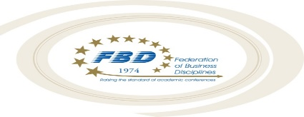
2023 Covid-related Policies and Information

FBD has updated our cancellation and refund policy for COVID-related reasons only to ensure individuals who are COVID positive are not tempted to attend the conference and potentially diminish the safety of our attendees. Those who receive a positive COVID test within the 10-day typical refund window, but before the start of the conference (deemed to be 11:00 a.m. on Wednesday, March 8th, 2023), may request a refund upon sufficient proof of the positive test result. The FBD fee will be returned to you. Each member association will make its own decision about refund of individual association fees.

If you suspect that you have been exposed to COVID and that you may put others at risk, we appeal to you to cancel your attendance and seek potential reimbursement from your home institution. Non-confirmed cases (e.g., no positive test) of COVID or exposure to COVID exposures will not suffice for purposes of a refund.

It is your responsibility to seek reimbursement for your fees from your home institution in the event of travel restrictions and/or illness related to Covid.

If you are experiencing symptoms, have been significantly exposed to Covid, or have received a positive Covid test result, it is your responsibility to withdraw from the conference and not expose others by attending.

FBD and its member associations are not responsible in the event you are exposed and/or contract Covid as a result of your attendance at the conference or as a result of your travel for the conference.

It is your responsibility to exercise the appropriate consideration so that you do not expose others to Covid nor potentially make others ill as a result of your exposure to Covid or other such contagious illnesses.

FBD will follow all safety protocols mandated by the State of Texas, City of Houston, and Hyatt Regency Houston and, thus, its attendees are expected to also follow those mandates.

Proof of Covid vaccination or a negative result from a Covid test may be required for participation in the FBD conference activities held in Houston, TX if local and/or other mandates exist.

